# PROJECT DESIGN PHASE-II DATA FLOW DIAGRAM

|  |  |
| --- | --- |
| Date | 15 October 2022 |
| Team ID | PNT2022TMID37319 |
| Project Name | University Admit Eligibility Predictor |
| Maximum Marks | 4 Marks |

**DATA FLOW DIAGRAMS:**

A Data Flow Diagram (DFD) is a traditional visual representation of the information flows within a system. A neat and clear DFD can depict the right amount of the system requirement graphically. It shows how data enters and leaves the system, what changes the information, and where data is stored.

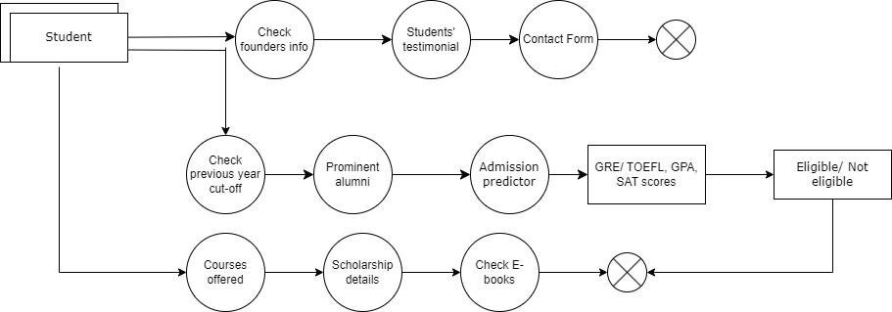

# USER STORIES:

Use the below template to list all the user stories for the product.

|  |  |  |  |  |  |  |
| --- | --- | --- | --- | --- | --- | --- |
| **USER TYPE** | **FUNCTIONAL**  **REQUIREMENT (EPIC)** | **USER**  **STORY NUMBER** | **USER STORY / TASK** | **ACCEPTANCE CRITERIA** | **PRIORITY** | **RELEASE** |
| Customer (Mobile user) | Registration | USN-1 | As a user, I will visit the home page of the website | I can access my account / dashboard | High | Sprint-1 |
|  |  | USN-2 | As a user, I will go to the prediction page | I can receive confirmation email & click confirm | High | Sprint-2 |
|  | Login | USN-3 | As a user , I will enter the information in the page. |  | High | Sprint-3 |
|  | Dashboard | USN-4 | As a user, I will view my prediction of chances of admit in the university. | It is viewed once the login is completed and a particular college is  selected. | High | Sprint-4 |
|  |  |  |  |  |  |  |
| Customer (Web user) |  | USN-1 | As a user, I will visit the home page of the website | I can access my account / dashboard | High | Sprint-1 |
|  |  | USN-2 | As a user, I will go to the prediction page | I can receive confirmation  email & click confirm | High | Sprint-2 |
|  | Login | USN-3 | As a user , I will enter the information in the page. |  | High | Sprint-3 |
|  | Dashboard | USN-4 | As a user, I will view my prediction of chances of admit in the university. | It is viewed once the login is completed and a particular college is  selected. | High | Sprint-4 |